**Overview of different types of addressing in computer networking**

Usually we use two types of addressing in computer networking named as Physical addressing (MAC address) and IP (internet protocol) Address.

**MAC (Media access control) Address**

MAC (Media access control) address is also known as physical address is a computer unique hardware number. Traditionally MAC (media access control) is 12-digit long (6 byte, 48 bits) Remember each digit has 4 bits. To get the physical address of your computer just follow the simple steps

1. Go to command prompt
2. 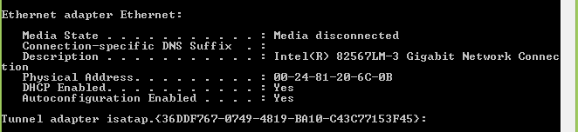In the command prompt enter ipconfig/all

The MAC (media access control) address of any computer never changes while IP address keeps changing from network to network.

Another simple way to find the mac-address of any computer is to type “getmac” without quote in command prompt .

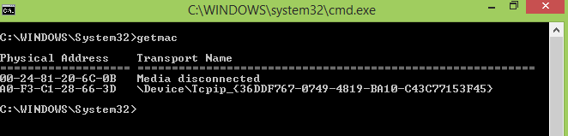

The information about manufacturer of NIC (network interface card) can be found using MAC (media access control) address.

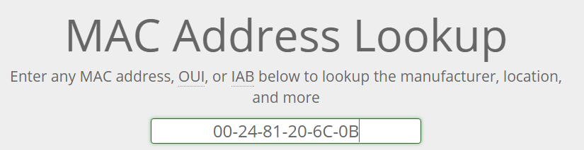 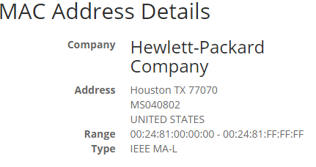

**IPV4 (Internet protocol) version four network**

There are two types of IP (internet protocol) named as IPV4 (internet protocol version 4) and ipv6 (internet protocol version 6) .IPV4 is 32 bits (8 digit) long and ipv6 is 128 bits (32 digits) long.

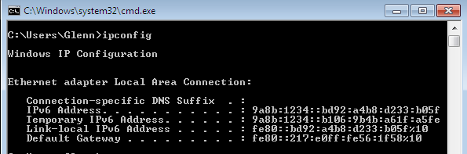

**IPv4 (internet protocol version four)**

IPV4 is most widely used version of internet protocol. It defines the connection of device (for example computer ,router) IP addresses in 32 bit format which looks like

192.168.1.1

Each section has a range from (0 to 255) it cannot be greater than 255) which means the total number of IPV4 (internet protocol version four) addresses are (256*256*256*256) or 2^32 = 4,294,967,296. This is the total number of IPV4 addresses that can be widely used.

Smart phones that are connected to internet have IPv4 (internet protocol address) and MAC address as well that uniquely identifies them

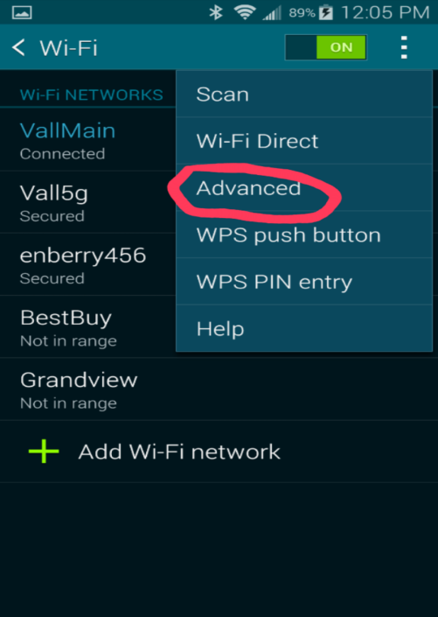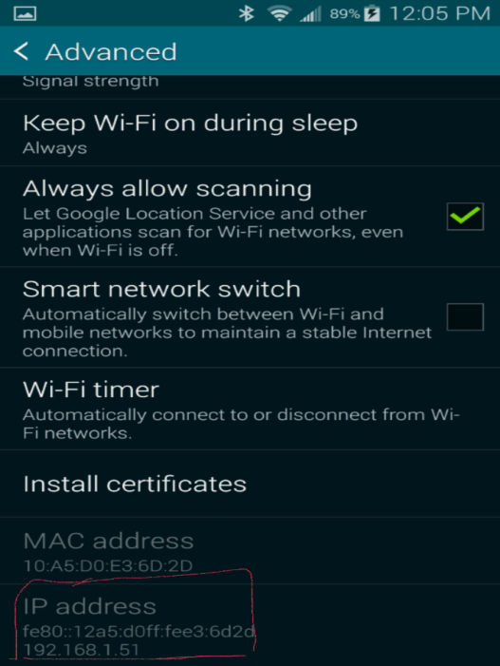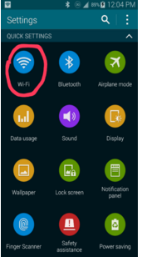

**IPV4 (internet protocol) notation**

1. **Binary ( in the form of 0, and one)**
2. **Dotted decimal notation ( using digits using from 0 to 9)**

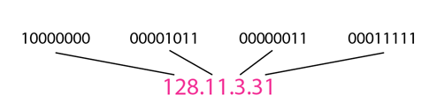

**How to convert from Binary to Decimal notation**

**The binary system has only two possible values(0 and 1) in contrast Decimal has ten values(0 ,1,2,3,4,5,6,7,8,9).**

**To avoid confusion write binary numbers are written with the base values like**  **.The decimal value 156 can be written as**  **and is read is (one hundred and fifty six base ten).  
Binary Languages is the languages that computers can understand the computer cannot understand decimal form so there is a need to convert Decimal in to binary and from binary to decimal .**

**Following steps are involved to convert Binary numbers to Decimal**

1. **List down the all numbers in the form of two for example to convert in to Decimal form**

**To convert from binary to decimal we can use the polynomial evaluation for example**

**101101012**

**1×27 + 0×26 + 1×25 + 1×24 + 0×23 + 1×22 + 0×21 + 1×20**

**= 128 + 32 + 16 + 4 + 1**

**=** **181**

**The right most bit will be 2^0 and will be incrementing by one from right to left .Means next bit will be having power of 1 and so on..**

**Example: convert the following binary numbers in to Decimal**

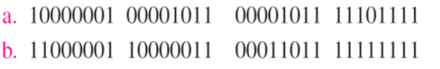

**Answer: By using the procedure mentioned you check you check**

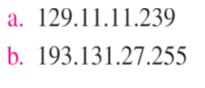

**Decimal to Binary conversion**

**To convert from Decimal to binary we cann**ot **use polynomial evaluation Following steps will be involved to convert from from decimal to binary**

* **Divide the Given digit in to two**
* **Reminders becomes new digit in this representation**
* **Digits are produced from right to left order**
* **stop when quotient becomes zero but use the corresponding reminder**

**Example: Convert 97 in to binary format**

**97 ÷ 2 🡺 quotient = 48, remainder = 1 (LSB)**

**48 ÷ 2 🡺 quotient = 24, remainder = 0.**

**24 ÷ 2 🡺 quotient = 12, remainder = 0.**

**12 ÷ 2 🡺 quotient = 6, remainder = 0.**

**6 ÷ 2 🡺 quotient = 3, remainder = 0.**

**3 ÷ 2 🡺 quotient = 1, remainder = 1.**

**1 ÷ 2 🡺 quotient = 0 (Stop) remainder = 1 (MSB)**

**Result = 1 1 0 0 0 0 1**

**LSB (least significant bit)**

**MSB (most significant bit)**

**Example: Find the error in the following IPV4 (internet protocol version four) address**

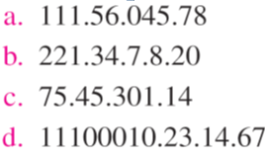

**Answers:**

1. **There must be no leading zero (So actual address can be 111.56.45.78)**
2. **There can’t be more than four member(X.X.X.X) but it has five numbers**
3. **Range used for IPV4 is (0-255) but here at number 3 digits are 301 that are why it’s wrong.**
4. **A mixture of binary and decimal is not allowed either it should be in decimal or binary.**

**Classes in IPV4 (internet protocol version 4)**

**The IP addressing in IPV4 is divided into classful addressing and classless addressing. Classful addressing is further divided into five classes (A,B,C,D,E) to check the IP address belongs to which class just check the first Digit and use these following ranges to find the class**

* **Class A (range 0-127)**
* **Class B(128-191)**
* **Class C(192-223)**
* **Class D(224-239)**
* **Class E (240-255)**

**In classful addressing if IP (internet protocol) address belongs to class A it can be written in the form of /8 for example 10.10.12.1 can be written as 10.10.12.1/8 . In this format /8 shows there are 8 bits for network and 24 for Hosts**

**In class B the host bits are 16 and networking bits are also 16 so IP addresses can be written in the form of /16. For example 172.16.1.1 can be written as 172.16.1.1/16 . For class C network bits are 24 and host bits are eight so can be written as /24. Example 192.168.1.1 can be written as 192.168.1.1/24**

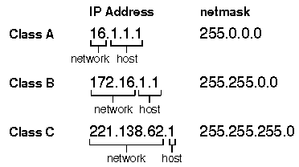

**Class D addresses are used to represent a group of hosts called host group or multicast means class D is used for one to many communication. While class A , B , C are used for unicast addressing(One to one communication) .**

**Class E is reserved for experimental purpose and should not be used for addressing hosts or multicast groups.**

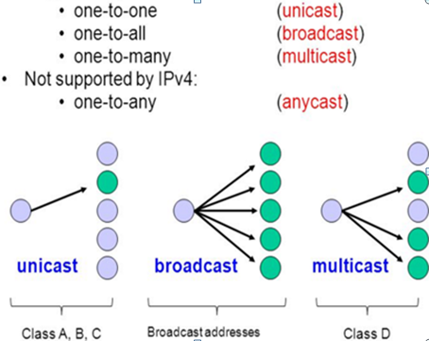

**Subnet mask**

Subnet mask is the mask used to determine what subnet an IP address belongs to .An IP address has two parts the network host and host address. IPV4 address has 32 bits in class A we have 8 bits for network address and 24 bits for hots portion. In class B 16 bits for network portion and 16 for host portion. While in class C network portion is 24 while host portion is 8 bits.

For classful addressing the subnet mask for class A is /8 that can be represented in binary form as

11111111.00000000.00000000.00000000 (if convert it in to decimal)

Subnet mask : 255.0.0.0 (For class A)

In class B subnet mask is /16

11111111.11111111.00000000.00000000(in binary form)

=255.255.0.0 (in decimal form)

For class C subnet mask is /24

=11111111.11111111.1111111.00000000(in binary form)

=255.255.255.0 (in decimal format)

To find the subnet mask if your computer just enter the command “ipconfig” without quote

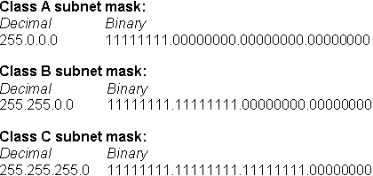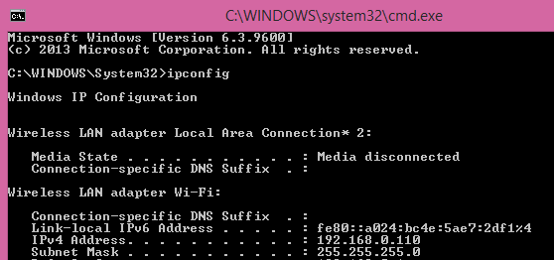

Hex

**Hexadecimal form**

**In mathematics or computing hexadecimal (also known as base 16) is used for representing real numbers**

**the Digits used for representing data in Hexadecimal form includes (0,1,2,3,4,5,6,7,8,9,A,B,C,D,E,F) WHERE**

**A = 10, B =11, C =12, D=13, E=14, F = 15.**

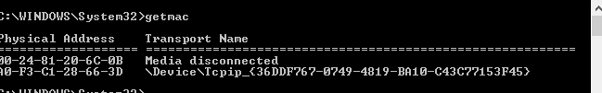**The MAC address of electronic device is usually in hexadecimal form.**

**Broadcast Address**

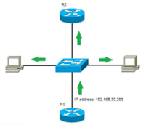

**Broadcast address is special type of networking address that is reserved for sending message to all nodes connected to local area network.**

**A broadcast address is usually MAC (Media access control) address consisting of all F’s (Remember MAC address has the length of 48 bits) so it will be (FFFF.FFFF.FFFF)**

On IP (internet protocol) addressing broadcast address is 255.255.255.255 that is equivalent to (0*FFFF.FFFF.FFFF) both are all ones in binary form.

* IP broadcast can be further divided into two types first one is limited broadcast and second one is Directed broadcast
* Limited broadcast is a type of broadcast that is performed by using IP address of 255.255.255.255. While for Directed broadcast we use broadcast address according to our network address. For example we are using Class A IP addressing to send data to all PC’s that’s are using class A IP addressing in our network.
* For limited broadcast addressing, Broadcast address is determined by inserting all 1’s in host portion.

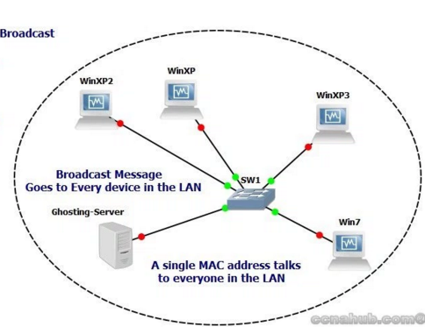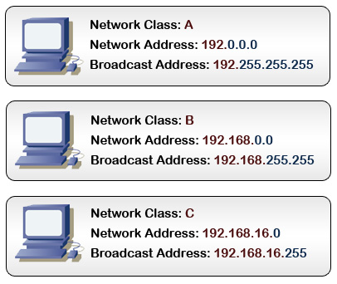

**How to configure STATIC IP address to Computer**

1. **Go to control Panel and** open networking settings

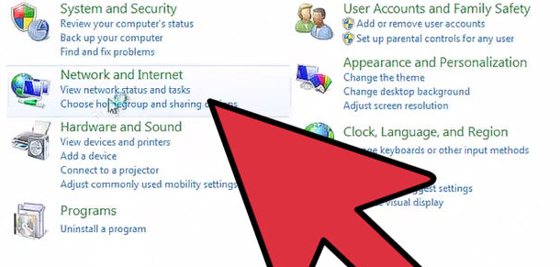

1. 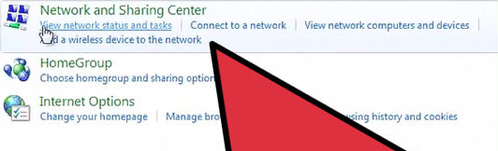
2. **at step number three find network connection that represent your connection to internet .**

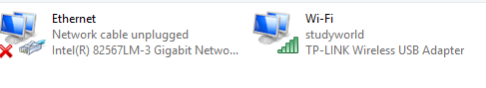

**Click on internet connection that you using then click on properties on “internet protocol version4(TCP/Ipv4) click on properties again to statistically configure IP address**

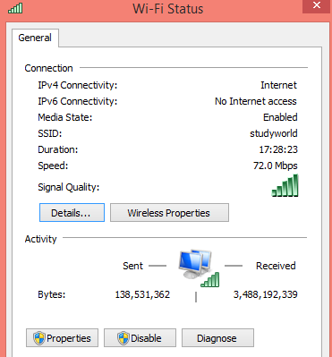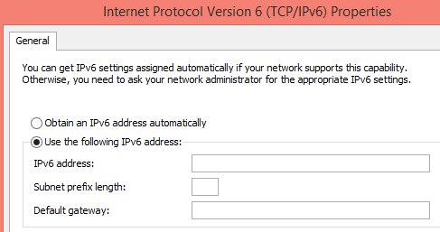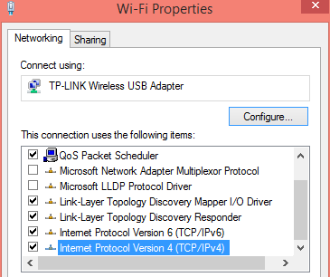

**Network Devices**

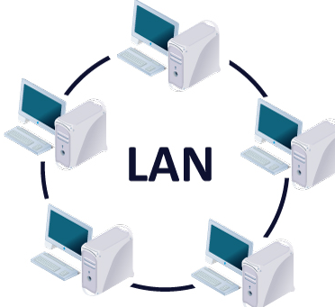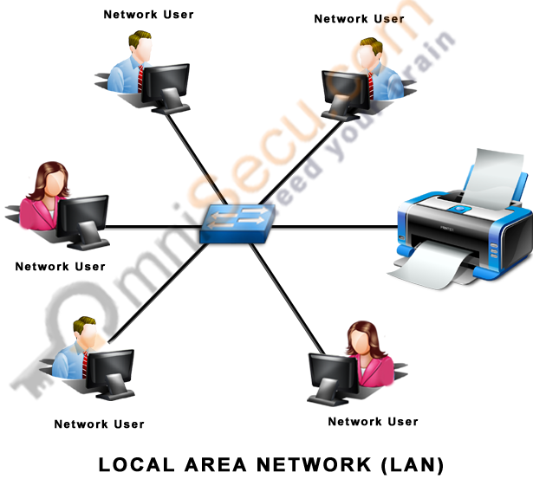**Network devices are components used to connect computers or other electronic devices together so that they can share files or resources like printers or fax machines devices .Devices used to setup LAN (Local area network). LAN (Local area network) connects computers and other networking devices in small area.**

**The mostly type of computer network types are**

1. **local Area network (LAN)**
2. **Wide area network (WAN)**
3. **Metropolitan Area network(MAN)**

**WAN (Wide area network)**

As the name suggests the network spans on wide area across provinces, across the country or even among the countries. These networks provides connectivity to MAN (metropolitan area network) and LAN (Local area networks)

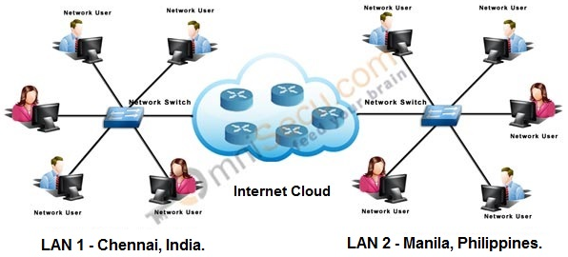**MAN (Metropolitan area network)**

**It is used to interconnects users with computer resources in geographical area or region that is larger than LAN(local area network ) and smaller than WAN(wide area network) .**

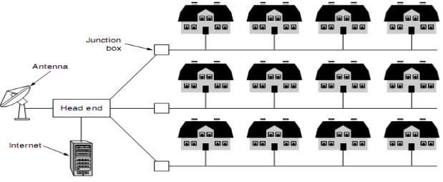

**Networking Devices**

**The most commonly used networking devices are followings**

**NIC (network interface card):**

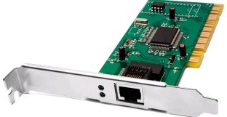 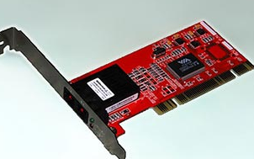

**Network interface card is a circuit board or card installed in a computer so that it can be connected to network .A network interface card provides a computer with dedicated , full connection to network .**

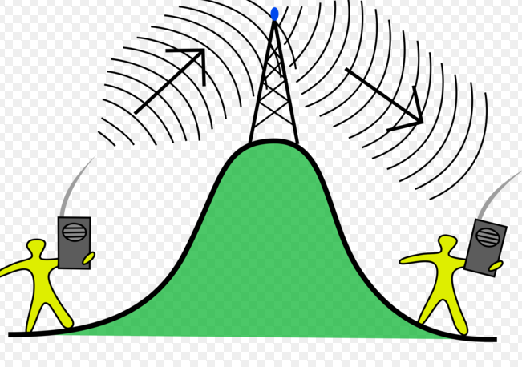**Repeater  
A repeater is a network device that is used to regenerate or replicate the signals that are weekend distorted by transmission over long distance. Generally Repeaters are categorized into two categories. Analog repeaters frequently can only amplify the signals while the digital repeaters can reconstruct the signals to near its original quality.**

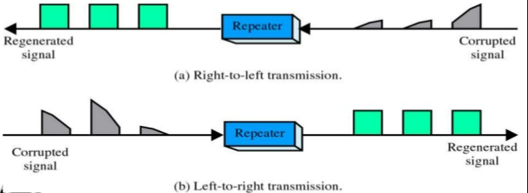

**ICONS for networking devices**

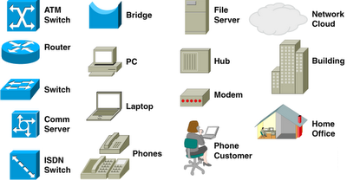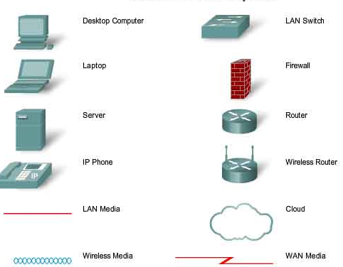

**HUB**

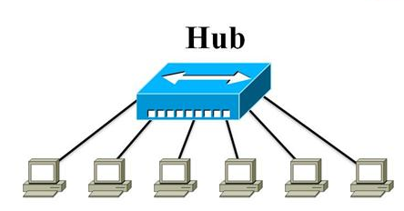**Hub is a common connection point for devices in network .A Hub contains multiple ports when packet arrives at one port , it is copied to other ports so that it can be accessed across the all network .**

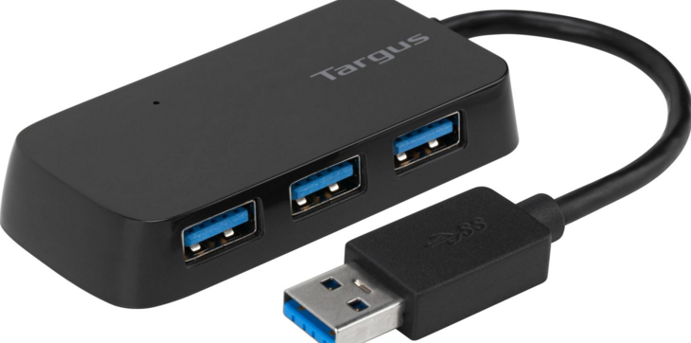

**Switch**

**A switch is like a hub but it is more intelligent than HUB .In the switch frames are forwarded based on MAC(Media access control) table unlike HUB when frames comes it is forwarded to all ports except the port it was received .**

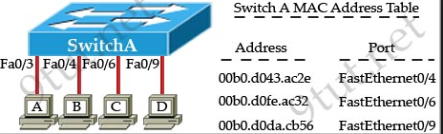

**If computer A wants to send some data to Computer D. First it will look into MAC (Media access control) table if MAC address of destination computer is available in MAC table data will be only forwarded to fa0/9 port only.**

**In case the MAC (media access control) address for PC D is not present in mac-address table the frame will be forwarded to all ports except fa0/3 (Because this is port where PC A wants to communicate with PC D).And once it has learned MAC address of host D it will not forwarded the packets to all destination .**

**Difference between HUBS and switches**

|  |  |
| --- | --- |
| **HUBS** | **Switches** |
| **Hub is least expensive device** | **Switch is more expensive than HUB** |
| **When frame comes to port it is forwarded to all outgoing ports .**   * **It does not have any MAC address table** | **When data is sent to particular PC it will only be forwarded to that particular PC.**   * **It has mac-address table to identifies where to send data** |
| **It uses Half duplex mode**   * **Half duplex means only data can travel only in one direction A device can only sent or receive at same time .Example walkie-talkie.** | **It uses full duplex.**   * **in full duplex data can travel in both side at the same time example of full duplex is Telephone call** |

In cisco switches we can use the command “show mac-address table” to check the all mac-addresses that switch knows.

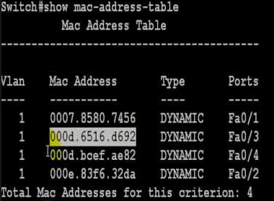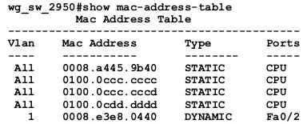

**Routers**

**A Router is a device that forward data packets along networks .A router is connected to at least two networks commonly two LAN(Local area networks) or WAN(wide area networks) . Routers are located at gateways where two networks interconnect.**

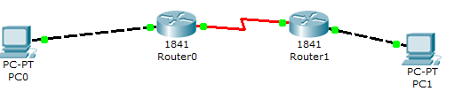

**One network Second network Third network**

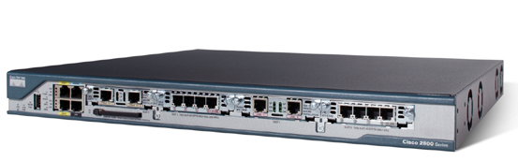

**Bridges**

**Bridges joins similar topologies and are also used to divide network segments. It can also filter the traffic based on mac-address table. Like switches if it is aware of destination address it will forward to that particular host else it will be forwarded to all outgoing ports.**

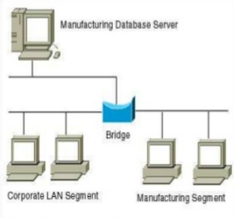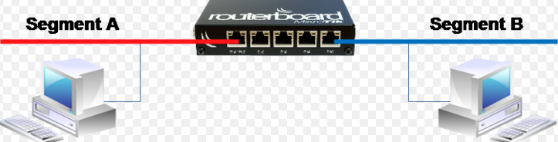

**Network Device Manufacturer**

**Networking hardware typically refers to equipment facilitating the use of computer networks. Typically this includes Routers, Access point, Switches, network interface card producer. The information about NIC (network interface card) can be obtained by using MAC address of any device that is always unique.**

**About the CISCO routers and switches information can be obtained by using a simple command (show version). Same command is used in cisco switches to retrieve the same information.**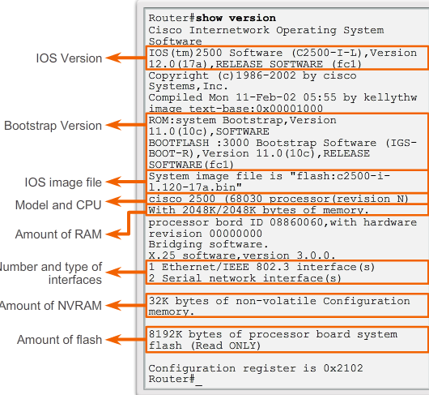

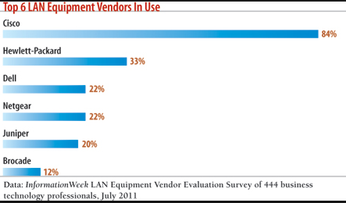**The biggest producers of networking equipment’s are CISCO, Juniper, Huawei, HP and** etc**. . . .**